When to Use Agents vs. Chat: Decision Framework

Summary
Decision framework based on task complexity, file count, iteration depth, cost, and risk tolerance.

The fundamental difference
Chat is reactive: you ask, AI responds, one exchange at a time. An agent is autonomous: it plans, executes, observes results, and iterates — operating in a loop without your intervention.

The Plan-Act-Observe-Adjust loop
Agents operate in a cycle:
Plan — Break the task into steps.
Execute — Write code, create files, run commands.
Observe — Read command output and test results.
Iterate — Fix problems based on observations.
Verify — Run tests to confirm correctness.

When to use chat
- Quick questions about code or concepts
- Explaining an error message or stack trace
- Small, single-file edits
- Code review of specific functions
- Learning and exploration

When to use agents
- Multi-file feature implementation
- Codebase-wide refactoring
- Test suite generation
- Bug investigation and fixing
- Framework or library migrations
- Any task with multiple steps that requires verification

Decision matrix
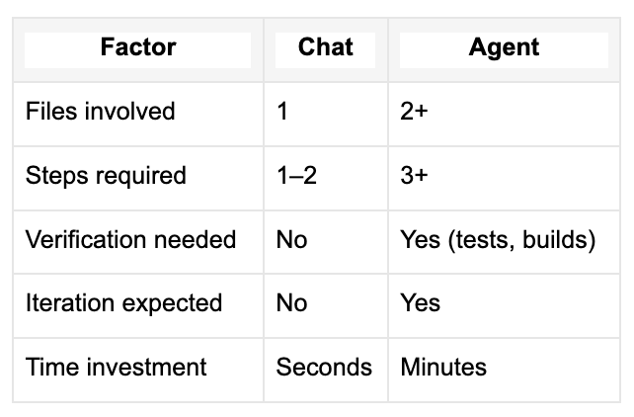

Agent types in 2026
Agents now come in multiple flavors:
- Local agents: interactive, run in your editor (Cursor Agent, Copilot local)
- Background agents: CLI-based, run in isolated Git worktrees
- Cloud agents: run on remote infrastructure, produce PRs (Copilot coding agent)
- Third-party agents: From providers like Anthropic (Claude Code) and OpenAI
You can hand off between agent types — start planning locally, then hand off to a cloud agent for implementation.

The test foundation
Agents work dramatically better when your project has tests. Tests are guardrails — the agent can run them after each change to verify correctness. Without tests, the agent may claim “done” when things are actually broken.
If you take one thing from this: invest in tests. Tests are the foundation that makes agents reliable.

